

St Modwen’s Catholic
Primary School

PARENT INFORMATION
PACK

Reception – Year 6

Dear Parents/Carers,

We consider it to be a great privilege that you have chosen our school to work in partnership with you in educating your child. The Governors and staff are committed to our Vision of ‘Excellence For All Through Jesus’ Love’ and at St Modwen’s your child with be nurtured in an environment where all children are encouraged to realise their potential. Our school encourages children to develop their personal relationship with God as they journey towards discovering their own self-worth and destiny through the values and virtues of Catholic teaching.

Our school Mission is to aim high and achieve our God-given potential as socially responsible citizens, loving one another as Jesus loves us.

Our school Values are:
Faith and Catholic Life Ensure our children develop a comprehensive understanding of out Catholic Faith, in line with Gospel values, which underpin the ethos of the school. Celebrating our faith in all that we do and by our actions provide witness of God’s love to the world.
Success Provide the highest quality of teaching and learning for all. Inspire our children to be passionate about learning and ensure all children experience success.
Partnership Develop an active partnership in learning with our families, the parish and the local and wider community, celebrating diversity.
Knowledge and Understanding Build on children’s knowledge and understanding so that they can achieve their God given potential.
Learning Experiences Make learning challenging and enjoyable within a curriculum which is creative, broad and balanced. Where every child has the opportunity to become a thinker, leader, organiser, communicator, explorer, creator, inventor, performer and artist.

Our school Aims are:
We strive for Respect To be kind to others through our care, compassion and love.
We strive for Enthusiasm To be always ready to embrace the journey ahead with eagerness and joy.
We strive for Independence To take responsibility for our learning with resilience and perseverance, becoming lifelong learners, accepting mistakes in ourselves and in others and learning from them.
We strive for Responsibility To be stewards of God’s creation and to be a voice for equality as socially responsible citizens.

Please find enclosed our Parent Information Pack, which includes:
- New Parents Information
- Attendance & Punctuality
- Parental Responsibility
- Parents/Carers car park safety rules and use of car park
- School Uniform information sheet
- Milk for Life
- Pupil Data and Common to All Privacy Notices
- Term Dates 2025/26

Our School Admissions Policy and information about the school and can be found on the school website: https://www.st-modwens.staffs.sch.uk/

Thank you again for choosing St Modwen’s and we look forward to many successful years ahead as we work together to help your child to be the very best they can.

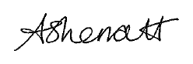
Yours sincerely

Mrs Andrea Sherratt
Head Teacher

- New Parents Information: Information to help your child’s transition into St Modwen’s Catholic Primary school as smooth as possible

To contact school by email or telephone: If you have an urgent message, the best way to contact school is via telephone on 01283 247560. Press option 1 for the absence line and option 2 for general enquiries.

office@st-modwens.staffs.sch.uk for messages about attendance, admissions and general enquiries.

Attendance: Good attendance in school is pivotal in pupils achieving their potential. Therefore, all children should be at school, on time, every day the school is open, unless the reason for the absence is due to exceptional circumstances. Parents are asked to ensure that their child is punctual for school. If a child arrives in school after the registers are closed, he/she will be marked as late. If this is after 9.15am in the morning, this is recorded as late after registration closes.

The school day for:
- EYFS (Reception) is from 8.55am till 3.20pm with lunch from 11.45am- 13:00pm
- Year 1 and Year 2 is from 8.55am till 3.20pm with lunch from 12.15pm – 13.15pm
- Years 3 - 6 is from 8.55am till 3.30pm with lunch from 12.15pm – 13.15pm

Reporting Absences: If a child is absent due to illness, parents should contact school on the first and each day of their child’s absence from school, before 9:00am. This can be done by email (office@st-modwens.staffs.sch.uk), via ParentMail or by telephone (01283 247560, option 1 for the absence line). If the phone is busy, please leave an answer message and if necessary a member of staff will return your call. The reason for absence should be fully explained i.e., please give the details of the illness. School can then decide which code to enter in the register.

School Monitoring of Attendance and Punctuality: School employs an Attendance and Admissions Officer to support the schools' stringent procedures for monitoring attendance and persistent absenteeism, as per Working together to improve attendance DfE guidance issued August 2024. School uses AStar to track and monitor school attendance.

Penalty notices: As a school we are obliged to inform you that you may be subject to a Penalty Notice if your child’s absence from school is unauthorised. This is in line with Staffordshire County Councils Code of Conduct.

Failure to pay the Penalty Notice could result in the Local Authority starting legal proceedings against you for the offence of failing to ensure your child’s regular attendance at school.

Request for an update of details: For the school to run effectively, communications in both directions between home and school are vital. School publishes a weekly newsletter, for those parents with email addresses this will be sent out electronically via ParentMail.

Data Collection (Arbor): It is vital that we have your updated information about children and families on our school database, in particular regarding contact information. Any changes i.e., change of address, mobile no. etc., please let the office know as soon as possible.

Medical Needs and information: Please let us know if your child has any new medical issues.

Drop Off and Collection: At the start and end of the school day traffic flow and pedestrian activity around the school is particularly high. We recognise there will be high volumes of traffic, although we encourage children to walk, cycle or car share to school if possible. We are committed to keeping everyone safe during drop off and collection and appreciate your co-operation with our systems. When collecting and dropping off using a vehicle, we ask that you drive, park and turn considerately, taking care not to cause obstructions and keeping an eye out for pedestrians. Children are the responsibility of parents whilst they are in the drop off areas - before and after the school day.

Collection from class: All parents will have completed an End of Day Procedure (EODP) form for each child. This is a procedure to further ensure the safety of all children when leaving school at the end of the school day. Class teachers will only release children once an adult listed on the EODP form has been seen. You will be able to update this list and other information about your child on Arbor (our Management Information System). Children in Y5 and Y6 who usually walk home without an adult can do so, only if this is indicated on the EODP form. (Children in Year 5 with permission will be able to walk home from the Summer term onwards.) This is also required for children who walk home with older siblings.
- All parents are asked to collect children from outside their classrooms, please stand to enable the class teacher to see all parents.
- Where there are two or more children in one family, parent should go to the class of their youngest child first.
- Children without consent to walk home on their own must be collected by persons over the age of 16 and recorded on EODP form.
Money in school: ParentMail is used for all payments.

Jewellery in school: Please be reminded that children should not wear fashion earrings or jewellery (including bracelets) for school. The current advice from health and safety service is that the wearing of any jewellery increases the risk of injury significantly and thus all jewellery, including earrings must be removed for PE and physical activities. Staff will not remove jewellery for children and so they must be able to do themselves in order to take part in PE lessons. No responsibility is taken by school, for looking after items of jewellery within school. The uniform policy for the school states that only a small piece of religious jewellery and a pair of stud earrings may be worn. Please support us in keeping all children safe at school.

ParentMail and Arbor: Once your child has started school, you will receive a link to set up your Arbor account and also your ParentMail account for your child, or to add your child if they already have siblings in school. This is used by the school to communicate with parents/carers and for payment items, school meals, trips, etc.

Breakfast and After-School club : We offer a school Wraparound Care Services from JAG (Junior Adventures Group)
For further details on the club, including our times and prices, please see their website.
www.junioadventuregroup.co.uk

Bookings are on a first-come-first-served basis and subject to availability. All bookings are made via the online booking system. More information can be found on the school website.

KS2 Dinner Money: A reminder to parents that dinner money is £3.30 per day (Autumn Term 2025) and is payable in advance for each half term, pre-book on ParentMail. All children in Reception, Y1 and Y2 are entitled to a school meal, free of charge, every day and we strongly encourage all KS1 pupils to have a school lunch. If there are circumstances that prevent your child from being able to have a school lunch, please call the office to arrange a meeting with the Headteacher.
- Attendance and Punctuality Guide for Parents/Carers

Attendance
St Modwen’s Catholic Primary School seeks to ensure that all its pupils receive a full-time education which maximises opportunities for each pupil to realise his/her true potential. The school will strive to provide a welcoming, caring environment, whereby each member of the school community feels wanted and secure. All school staff will work with pupils and their families to ensure each pupil attends school regularly and punctually.

School is supporting Staffordshire County Council Little Heroes campaign to focus on:
HERE
EVERY DAY
READY
ON TIME

The school has established an effective system of incentives and rewards that acknowledges the efforts of pupils to improve their attendance and timekeeping and will challenge the behaviour of those pupils and parents who give low priority to attendance and punctuality. To meet these objectives St Modwen’s Catholic Primary School works with pupils, parents and appropriate agencies to provide mutual information, advice and support

Why is good attendance important?
Good attendance and punctuality are vital for success at school, and to establish positive life habits that are necessary for future success.
Through regular attendance, pupils can:
- Build friendships and develop social groups.
- Develop life skills.
- Engage in essential learning and other school social events.
- Achieve to their full potential.
- Minimise the risk of engaging in anti-social behaviour

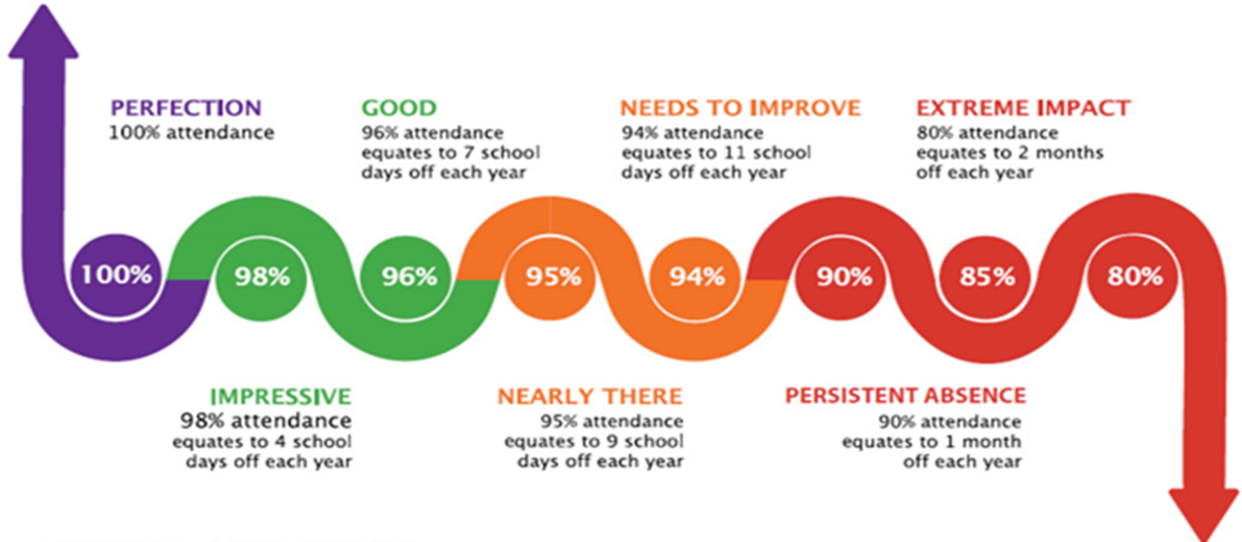
Punctuality
School gates close at 8.55am and arrival at school after this time, without prior approval or extenuating circumstances, will be recorded as ‘late after registration closed’. Pupils arriving at school after 8.55am must enter through the main gates and report to the school office to be signed in by an adult. Pupils leaving school for any reason must report to the office before they go so that we can ensure that they are appropriately chaperoned and signed out. Registers are also taken when the children return to classes after lunch. Unexplained absences will be investigated by our school attendance lead.

What is expected of the pupils?
- To respect themselves and others
- To do all they can to attend school regularly and punctually
- To inform a trusted adult if they feel that they are being bullied
- To encourage friendship and a sense of belonging
- To be happy and encourage others to feel happy

What is expected of the Parents?
- To keep requests for their child to be absent to a minimum
- To offer a reason, or medical proof, for any period of absence, preferably before the absence or on the first day of absence
- To ensure that their child arrives at school on time, a reason should be offered for any lateness
- To work closely with the school to resolve any problems that may impede a child’s attendance
- To take family holidays during school holiday periods and be aware that requests for holidays during term time will be refused except in emergency/exceptional circumstances.
- To be aware of curriculum requirements and be especially vigilant with regards to attendance during important academic times such as SATS
- Take an interest in your child’s school work, support and recognise their successes and achievements. Make sure your child understands that you do not approve of absence from school
- Support our school in our efforts to control inappropriate behaviour
- Inform us on the first day of your child’s absence, and keep us updated throughout the absence period
- Provide us with at least two emergency contacts for your child.

Frequently asked Questions - Attendance

What does the law say?
All children of compulsory school age – between 5-16 – must receive a suitable full-time education. As a parent, you are responsible for ensuring that this happens, either by registering your child at a school or by making appropriate alternative arrangements.

Once you have registered your child at a school, you are also legally responsible for ensuring that your child attends school regularly. If you fail to do this – even if your child misses school without you knowing – legal action can be taken against you by the Local Authority. It is a legal offence to fail to ensure your child attends school regularly.

Can my child take a holidays during term time?
The school will not authorise an absence for a holiday during term time, unless in exceptional circumstances. Taking holidays during term time means that pupils miss important school time – both educationally and for other school activities. It will be difficult for children to catch up on work when they return to school. Only in exceptional circumstances may an absence be authorised during term time – this will be decided by the Headteacher. Exceptional circumstances do not involve cheaper costs, family availability or weather conditions.

Can my child ever be absent?
When a pupil is absent from school, this will be classified as either ‘authorised’ or ‘unauthorised.’ You can be fined if you take your child on holiday during term time without permission from the Headteacher.

The Headteacher decides which absences are granted as authorised. Authorised absences are only permitted for valid reasons such as:
• Illness.
• Medical or dental appointments.
• Religious observances.
• Family bereavement.

Wherever possible, parents should always try to arrange medical and dental appointments during school holidays or after school hours. If medical needs cause a prolonged absence evidence is required to support this and a medical care plan put in place. Learning will be sent home in such circumstances.

What are unauthorised absences?
Unauthorised absences are those which the school does not approve. Unauthorised absences reasons can include:
- Forgetting school term dates.
- Oversleeping.
- Absences which have not been explained.
- Leaving school for no reason during the day.
- Keeping pupils off school unnecessarily or without explanation.
- Day trips or family outings.
- Problems with uniform/clothing.
- Car breaking down
- Birthdays and holidays.
- Parental illness unless in exceptional circumstances.

- Parental Responsibility
Schools are required by law to have a wide range of dealings with pupils' parents. Schools can find themselves caught up in disputes between a number of adults, each claiming to have parental responsibility for a particular child.

Some basic guidelines are given below. These provide general guidance but schools may want to take their own independent legal advice about any particular individual set of circumstances. The terms 'resident' and 'non-resident' parent are used to distinguish between parents who do and do not live with a child.

Definition of parent
Section 576 of the Education Act 1996 defines 'parent' as
- all natural parents, whether they are married or not
- any person who, although not a natural parent, has parental responsibility for a child or young person
- any person who, although not a natural parent, has care of a child or young person (having care of a child or young person means that a person with whom the child lives and who looks after the child, irrespective of what their relationship is with the child, is considered to be a parent in education law).

Parental responsibility
Having parental responsibility means assuming all the rights, duties, powers, responsibilities and authority that a parent of a child has by law. People other than a child's natural parents can acquire parental responsibility through
- being granted a residence order
- being appointed a guardian
- being named in an emergency protection order (although parental responsibility in such a case is limited to taking reasonable steps to safeguard or promote the child's welfare)
- adopting a child
- (in the case of step-parents) in agreement with the child's mother (and other parent if that person also has parental responsibility for the child) or as the result of a court order.
- Where a child's parents are not married to each other, the child's father can gain parental responsibility by
- registering the child's birth jointly with the mother
- through a 'parental responsibility agreement' between him and the child's mother
- as the result of a court order.

In addition, a local authority can acquire parental responsibility if it is named in the care order for a child

Court orders and parental responsibility
Court orders under section 8 of the Children Act 1989 (often called section 8 orders) settle areas of dispute about a child's care or upbringing, and can limit an individual's parental responsibility.

General principles for schools
Everyone who is a parent, as defined above (whether they are a resident or non-resident parent) has a right to participate in decisions about a child's education and receive information about the child (even though, for day-to-day purposes, the school's main contact is likely to be a parent with whom the child lives on school days).
School and LA staff must treat all parents equally, unless there is a court order limiting an individual's exercise of parental responsibility. Individuals who have parental responsibility for, or care of, a child have the same rights as natural parents, for example
- to receive information, e.g. pupil reports
- to participate in activities, e.g. vote in elections for parent governors
- to be asked to give consent, e.g. to the child taking part in school trips
- to be informed about meetings involving the child, e.g. a governors' meeting on the child's exclusion.
- Where a parent's action, or proposed action, conflicts with the school's ability to act in the child's best interests, the school should try to resolve the problem with that parent but avoid becoming
- involved in conflict.

Administration
Headteachers should
- ask parents or guardians for the names and addresses of all parents when they register a pupil
- ensure that names and addresses of all parents, where known, are included in the admission register and also in pupil records and are available to the pupil's teachers
- ensure that names and addresses of all parents are forwarded to any school to which the pupil moves
- ensure that details of court orders are noted in a pupil's record
- where the address of a non-resident parent is unknown, tell the resident parent that the non-resident parent is entitled to be involved in their child's education and ask that information is passed on to them.

Obtaining consent
Where schools need parental consent to outings and activities, headteachers should seek the consent from the resident parent unless the decision is likely to have a long-term and significant impact on the child or the non-resident parent has requested to be asked for consent in all such cases.

In cases where the school considers it necessary to seek consent from both parents, it is possible that one gives consent and the other withholds it. When this happens it is best to assume that parental consent has not been given. Such an approach safeguards the position of the school, ensuring that it is not exposed to any potential civil liability if, for example, the child is injured while on the school trip.

Changing a surname
A change of surname is a private law matter and should be resolved between parents. Where the parents have divorced, schools should ensure that the surname by which a child is known should not be changed without written evidence (independent of the parent seeking to make the change), that consent has been given by the 'other parent' or by anyone else who has parental responsibility for the child. However, there may be circumstances where a name change has already been effected by the school and therefore it would not be in the best interests of the child who might be known by a new name to refer back to a different name. Ultimately it is a matter of policy for the school to decide but the best interests of the child must be the paramount consideration when making a decision.

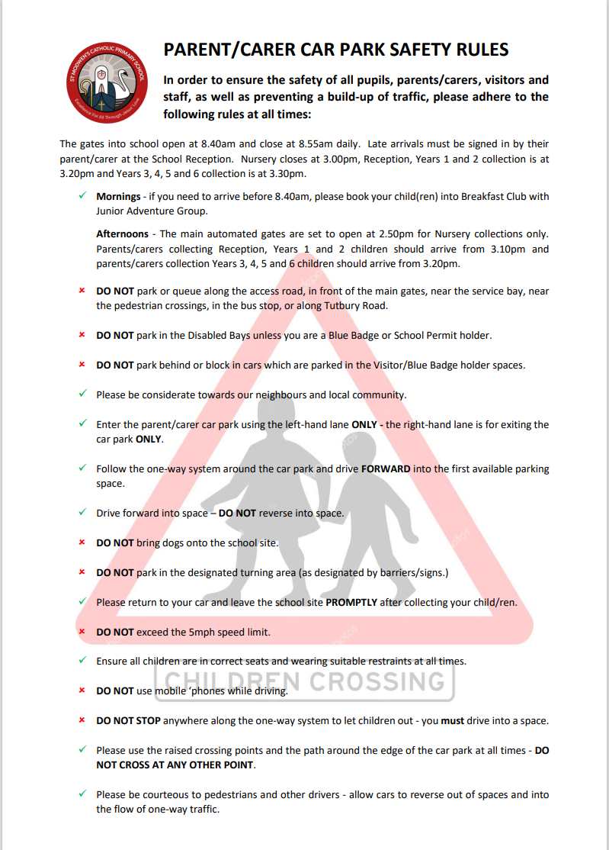
- Parent/carer car park safety rules and use of car park
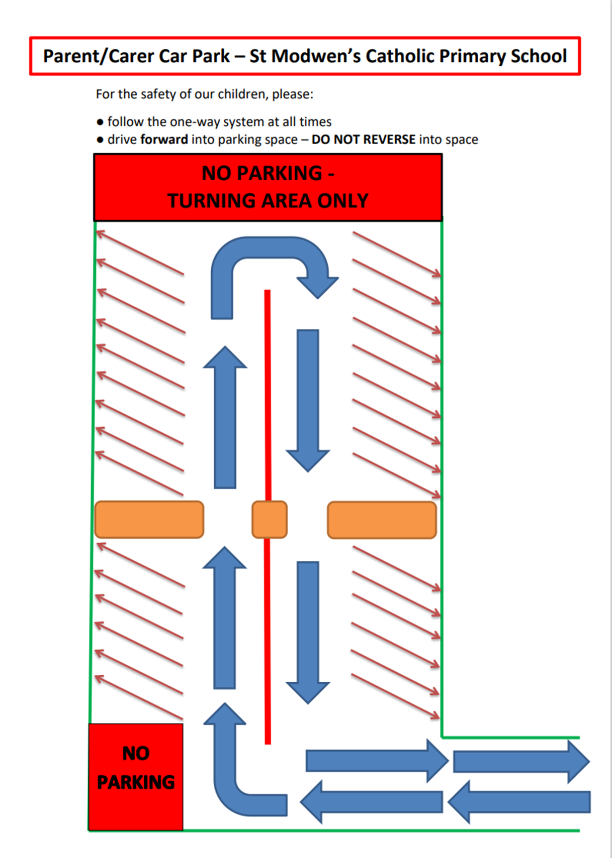

- School Uniform information sheet
Our school uniform is supplied by:

- My Uniform, 82 Wellington Street, Burton-on-Trent, DE14 2DS. Telephone 01283 619224
- Online Clothing Solutions www.schoolwearuk.co.uk

Boys | Girls
- compulsory – red jumper or cardigan (preferably with school badge)  - white collared shirt – not polo shirt  - school tie  - grey school trousers  - grey shorts – optional for summer  - black, white, red, or grey socks  - school book bag  - black school shoes with low heel (with laces or Velcro strap or buckle strap – no open toed sandals | - compulsory - red jumper or cardigan (preferably with school badge)  - white collared shirt – not polo shirt  - school tie  - grey school trousers, skirt or pinafore  - red and white gingham dress (optional for summer)  - white, red or grey socks or tights  - school book bag  - black school shoes with low heel (with laces or Velcro strap or buckle strap) – no open toed sandals

PE Kit
- red polo shirt (school badge preferred)
- black shorts
- black plimsolls/pumps essential for indoor PE

When children in Y1-Y6 are timetabled for outdoor PE in cold weather, they should bring:

- trainers (children will not be allowed out in their plimsolls)
- plain sports tracksuit bottoms and tracksuit top or sweatshirt, in school colours (black, grey or red)

For children in KS1, please put a spare pair of pants and socks in your child’s pump bag in case of little accidents.

Safety
- long hair must be tied back at all times
- stud earrings only and these must be removed for PE

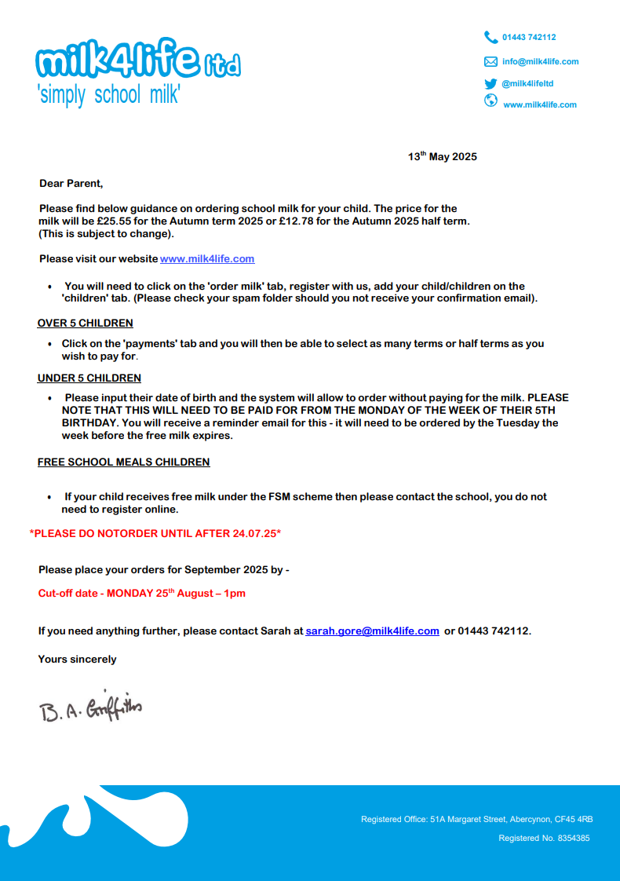
  - Milk 4 Life

Policy for:  Privacy Notice: Pupil Data |  |  |  |  |   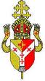
Committee: Premises, Health and Safety
Document Control
A. Confidentiality Notice
This policy document has been approved by the Governing body of St.Modwen’s Catholic Primary School and is intended for internal and /or external publication. Where the document is identified for internal use the policy information may not be shared with external agencies or parents without the prior agreement of the Headteacher or authorising Committee.
B. Document Details
Classification: |  | Premises, Health and Safety
Policy Source: |  | John Walker Model Policy (Published September 2024)
Organisation: |  | St. Modwen’s Catholic Primary School
Document Reference: |  | STM53
Current version number: |  | 24/25 V2 (5 pages)
Current Document Approved by: |  | Premises, Health and Safety
Date Approval: |  | 12.11.2024
Scheduled Review: |  | November 2025 (Annually)
C. Document Revision and Approval History
Version | Date | Version Created by | Version Approved by | Comments
24.25 V2 | 6.11.2024 | C Salt (SBM) | Premises, Health and Safety 12.11.2024 | Revised November 2024 – John Walker Model Policy (October 2023 version)  Updated School Branding
V1 | 7.11.2023 | School | PH&S | Amends: Staff Photographs paragraph added
7. Privacy Notice – Pupil Data

Privacy notice – pupil data

Introduction
As a school we collect a significant amount of information about our pupils. This notice explains why we collect the information, how we use it, the type of information we collect and our lawful reasons to do so.

Why do we collect data?
We collect and use pupil data to:
- fulfil our statutory obligations to safeguard and protect children and vulnerable people
- enable targeted, personalised learning for pupils
- manage behaviour and effective discipline
- monitor our effectiveness
- comply with our legal obligations to share data
- support pupils to fulfil their potential
- keep pupils, parents and carers informed about school events and school news

Our legal obligations
We must make sure that information we collect and use about pupils is in line with the UK GDPR and Data Protection Act 2018. This means that we must have a lawful reason to collect the data, and that if we share that with another organisation or individual, we must have a legal basis to do so.
The lawful basis for schools to collect information comes from a variety of sources, such as the Education Act 1996, Regulation 5 of The Education (Information About Individual Pupils) (England) Regulations 2013, Article 6 and Article 9 of the UK GDPR.
The Department for Education (DfE) and Local Authorities (LA) require us to collect certain information and report back to them. This is called a ‘public task’ and is recognised in law as it is necessary to provide the information.
We also have obligations to collect data about children who are at risk of suffering harm, and to share that with other agencies who have a responsibility to safeguard children, such as the police and social care.
We also share information about pupils who may need or have an Education Health and Care Plan (or Statement of Special Educational Needs). Medical teams have access to some information about pupils, either by agreement or because the law says we must share that information, for example school nurses may visit the school.

Sharing information
Other services, organisations and people we may share information with include:
- schools or academies that the students attend after leaving us
- relevant local authority/(ies)
- youth support services (students aged 13+)
- the Department for Education (DfE)
- the NHS as required
- school nursing service
- parent/carer
- suppliers and service providers
- health professionals
- health & social welfare organisations
- professional bodies
- charities and voluntary organisations
- auditors
- survey & research organisations
- social care organisations
- police forces and court services
- suppliers of software and apps that are used in the school
We must keep up to date information about parents and carers for emergency contacts.

How we use the data
In school we also use various third-party tools to make sure that pupils best interests are advanced. We also record details about progress, attainment and pupil development to support future planning and learning.
We use data to manage and monitor pastoral needs and attendance/absences so that suitable strategies can be planned if required.
We use systems to take electronic payments for school meals. This includes financial software to manage school budgets, which may include some pupil data. We use software to track progress and attainment.
Data can be used to monitor school effectiveness, the impact of intervention and learning styles across groups of pupils as well as individual children.
We may use consultants, experts and other advisors to assist the school in fulfilling its obligations and to help run the school properly. We might need to share pupil information with them if this is relevant to their work.
We also use contact information to keep pupils, parents, carers up to date about school events.

What type of data is collected?
The DfE and government requires us to collect a lot of data by law, so that they can monitor and support schools and academies more widely, as well as checking on individual schools and academies effectiveness.
The categories of pupil information that the school collects, holds and shares include the following:
- personal information – e.g. names, dates of births, pupil numbers and addresses
- characteristics – e.g. ethnicity, vulnerability categories, language, nationality, country of birth and free school meal eligibility
- attendance information – e.g. number of absences and absence reasons
- assessment information – e.g. national curriculum assessment results
- relevant medical information and social care
- information relating to SEND and health needs
- behavioural information – e.g. number of temporary exclusions
- CCTV, photos and video recordings

The National Pupil Database (NPD)
The NPD is owned and managed by the DfE and contains information about pupils in schools/academies in England. It provides invaluable evidence on educational performance to inform independent research, as well as studies commissioned by the department. It is held in electronic format for statistical purposes. This information is securely collected from a range of sources including schools, local authorities and awarding bodies.
We are required by law, to provide information about our pupils to the DfE as part of statutory data collections such as the school census and early years’ census. Some of this information is then stored in the NPD. The law that allows this is the Education (Information About Individual Pupils) (England) Regulations 2013.
To find out more about the pupil information we share with the department, for the purpose of data collections, go to https://www.gov.uk/education/data-collection-and-censuses-for-schools.
To find out more about the NPD, go to https://www.gov.uk/government/publications/national-pupil-database-user-guide-and-supporting-information.
The department may share information about our pupils from the NPD with third parties who promote the education or well-being of children in England by:
- conducting research or analysis
- producing statistics
- providing information, advice or guidance
The department has robust processes in place to ensure the confidentiality of our data is maintained and there are stringent controls in place regarding access and use of the data. Decisions on whether DfE releases data to third parties are subject to a strict approval process and based on a detailed assessment of:
- who is requesting the data
- the purpose for which it is required
- the level and sensitivity of data requested: and
- the arrangements in place to store and handle the data
To be granted access to pupil information, organisations must comply with strict terms and conditions covering the confidentiality and handling of the data, security arrangements and retention and use of the data.
For more information about the department’s data sharing process, please visit:
https://www.gov.uk/data-protection-how-we-collect-and-share-research-data
For information about which organisations the department has provided pupil information, (and for which project), please visit the following website: https://www.gov.uk/government/publications/national-pupil-database-requests-received To contact DfE: https://www.gov.uk/contact-dfe

Immunisations and Vaccinations
The Department for Education has issued new guidance since December 2023 explaining that schools must share information with the School Age Immunisation Services, who are commissioned by NHS England to deliver school-based immunisation programmes. Information that is to be shared on request includes a list of eligible children and young people and their parent or carer's contact details to the SAIS team.
The immunisation process is a matter of consent between the pupil, parent and or carer and the SAIS provider. The school do not take any active role in the process. The obligation to share data is within public task and does not rely upon consent. It is mandatory for the school to share this information.

Requesting access to your personal data
Under data protection legislation, parents and pupils have the right to request access to information about them that we hold. To make a request for your personal information, or be given access to your child’s educational record, contact School Business Manager. You also have the right to:
- object to processing of personal data that is likely to cause, or is causing, damage or distress
- prevent processing for the purpose of direct marketing
- object to decisions being taken by automated means
- in certain circumstances, have inaccurate personal data rectified, blocked, erased or destroyed; and
- claim compensation for damages caused by a breach of the Data Protection regulations
If you have a concern about the way we are collecting or using your personal data, you should raise your concern with us in the first instance or directly to the Information Commissioner’s Office at https://ico.org.uk/concerns/.

Contact
If you would like to discuss anything in this privacy notice, please contact School Business Manager.

More information about data protection and our policies
How we manage the data and our responsibilities to look after and share data is explained in our data protection policy, and connected policies, which are also available on our website.
If you feel that data about your child is not accurate, or no longer needed please contact the school office. Our complaints policy explains what to do if there is a dispute. Subject Access Requests are dealt with by the specific policy on the website.

Review
The school will update this privacy notice from time to time. Any substantial changes that affect your rights will be provided to you directly as far as is reasonably practicable.

Common to all privacy notices
Policy for:
Privacy Notice: Common to all 2024/25
Committee: Premises, Health and Safety
Document Control
A. Confidentiality Notice
This policy document has been approved by the Governing body of St.Modwen’s Catholic Primary School and is intended for internal and /or external publication. Where the document is identified for internal use the policy information may not be shared with external agencies or parents without the prior agreement of the Headteacher or authorising Committee.
B. Document Details
Classification: |  | Premises, Health and Safety
Policy Source: |  | John Walker Model Policy (Published March 2024)
Organisation: |  | St. Modwen’s Catholic Primary School
Document Reference: |  | STM53
Current version number: |  | 24/25 V2 (3 pages)
Current Document Approved by: |  | Premises, Health and Safety
Date Approval: |  | 12.11.2024
Scheduled Review: |  | November 2025 (Annually)
C. Document Revision and Approval History
Version | Date | Version Created by | Version Approved by | Comments
24.25 V2 | 5.11.2024 | C Salt (SBM) | Premises, Health and Safety 12.11.2024 | Revised November 2024 – John Walker Model Policy (December 2023 version)
V1 | 7.11.2023 | School | PH&S | The legal grounds for using your information para 3 and 4 added. J Walker Policy update 23.24.
Privacy notice: common to all

THE LEGAL GROUNDS FOR USING YOUR INFORMATION
This is common for all personal and sensitive data we collect and process about staff, volunteers, pupils, parents, carers and any other individuals.

Some data is more sensitive than other types of data. These special categories are as follows: personal information revealing racial or ethnic origin, political opinions, religious or philosophical beliefs, trade union membership, genetic information, biometric information, health information, and information about sex life or orientation.

Telephone calls may be recorded for training and monitoring purposes.

CCTV is installed and is subject to appropriate controls, more details can be found in the CCTV policy on the website.

CONSENT
The school will ask for consent to process data about you or a pupil. The type of data that is to be used, and how it is to be used will be specified on the consent forms.

You have the choice to opt in for certain types of data usage, and this is made clear. However, some data that is collected and processed in schools is not optional.

LEGITIMATE INTERESTS
This means that the processing is necessary for legitimate interests except where the processing is unfair to you. The school relies on legitimate interests for many of the ways in which it uses information.

Specifically, the school has a legitimate interest in:
- providing educational services to pupils
- safeguarding and promoting the welfare of pupils and staff
- promoting the objects and interests of the school
- ensuring the efficient operation of the school
- compliance with all relevant legal obligations of the school
- keeping the whole trust community informed about events, news and activities.

NECESSARY FOR CONTRACT
Information relating to individuals may be necessary to perform the school obligations under our contracts. For example, maintaining the academy management information system (MIS) database.

LEGAL OBLIGATION
Much of school life is governed by legal obligations to supply information to organisations such as the Department for Education or Local Authority or HMRC. We may also have to disclose information to third parties such as the courts, Disclosure and Barring Service or the police where legally obliged to do so.

VITAL INTEREST
Information is shared in the interest of the data subject. For example, to prevent someone from being seriously harmed or killed.

PUBLIC INTEREST
We are acting in the public interest when providing education. Certain regulations, DfE, local authority, health and other guidance require us to process data in the public interest.

LEGAL CLAIMS
The processing is necessary for the establishment, exercise or defence of legal claims. This allows us to share information with our legal advisors and insurers.

Your rights
- you can ask what information we hold about you and be provided with a copy. Sometimes we are not able to share all the information, but this is set out in our Subject Access Request protocol and procedure
- if information is incorrect, you can ask us to correct it
- you can ask us to delete the information that we hold about you or your child in certain circumstances. For example, where we no longer need the information
- you can ask us to send you, or another organisation, certain types of information about you in a format that can be read by computer – this does not apply to pupil records as these are transferred by a DfE process called the Common Transfer File
- our use of information about you may be restricted in some cases. For example, if you tell us that the information is inaccurate, we can only use it for limited purposes while we check its accuracy
If you disagree with any decision we make about your data you can use our complaints policy, you also have the right to make a complaint to the Information Commissioner, and sometimes to the Information Tribunal or through the court process. Our complaints policy is available on the website.

REVIEW
The trust will update this privacy notice from time to time. Any substantial changes that affect your rights will be provided to you directly as far as is reasonably practicable.

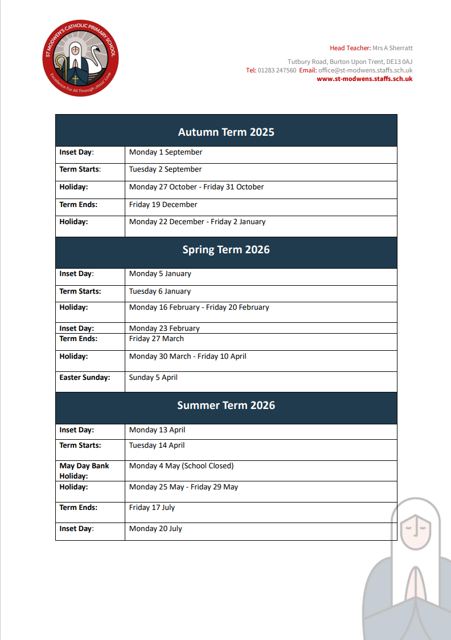
- Term Dates 2025 -26

