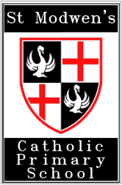

Is your child eligible for Free School Meals?

How do I find out?

If you are a parent or carer, and receive any of the benefits below, then your child is eligible for Free School Meals.

- Income Support
- Income Based Jobseekers Allowance
- Support under Part VI of the Immigration and Asylum Act 1999
- Child Tax Credit (provided you are not also entitled to Working Tax Credit and have an annual gross household income of no more than £16,190)
- The Guaranteed Element of State Pension Credit
- Income Related Employment and Support Allowance
- Working Tax Credit run on – paid for 4 weeks after you stop qualifying for Working Tax Credit

What to do next?

If your application for Free School Meals is successful, St Modwen’s Catholic Primary School will also receive extra funding from the Government to use in support of teaching and learning (Pupil Premium).
If you would like to apply for Free School Meals you can:

- Apply online at https://www.cloudforedu.org.uk/ofsm/link2ict
- Ask at reception for details

