Saint Modwen’s Primary School
Excellence for all through Jesus’ love
Times Tables Strategies
The aim of this booklet is to showcase some of the strategies we use in school to teach times tables so that you can use some of them at home to support your child in learning their times tables.
Times tables knowledge underpins much of the Maths curriculum and the sooner your children become fluent with their times tables, the easier it is for them to access and understand new and increasingly complex topics.
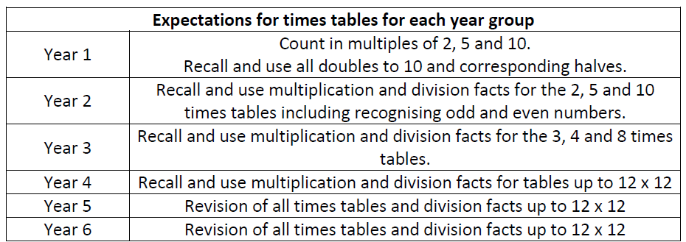
In addition, the Department of Education has introduced a compulsory times tables test for all Year 4 pupils.

Chanting
Many of us learnt our times tables likes this. It is a useful technique when used alongside other strategies.

Example 1 - Times
1 times 3 is 3, 2 times 3 is 6, 3 times 3 is 9
Example 2 - Are
Three ones are 3, three twos are 6 , three threes are 9
Example 3 – Step Counting up and down
3, 6, 9, 12, 15 …
15, 12, 9, 6, 3
Example 4 - Division
9 divided by 3 is 3, 12 divided by 3 is 4, 15 divided by 3 is 5
Tips
- Practise chanting backwards and forwards.
- Start from different places.
- Match memorable actions to the times tables facts which are hardest to remember.
- Use posters or post it notes to aid chanting and then remove this support.

Singing
2 | https://www.bbc.co.uk/bitesize/topics/zqbg87h/articles/zc7ygdm  https://www.youtube.com/watch?v=9C4EN7mFHCk&list=PLaSZ7kwwxKqXpdLA0hIA9fa8RVmRC32pv (Justin Timberlake)  https://www.youtube.com/watch?v=BGWMPqh04o4  https://www.youtube.com/watch?v=BHv6TBHxHHU&t=65s
3 | https://www.youtube.com/watch?v=uV0ZL2h8IRg  https://www.youtube.com/watch?v=1OPTfVcoCO4  https://www.youtube.com/watch?v=uneATAeac7Q (Moana)
4 | https://www.youtube.com/watch?v=8QU_E0u-tP4 (Elton John)  https://www.youtube.com/watch?v=TDxwIDtdMk4 (Chain Smokers)  https://www.youtube.com/watch?v=Zbgb11VJtVQ
5 | https://www.youtube.com/watch?v=vCjt1dbhvWU  https://www.youtube.com/watch?v=o7Jo26EyoYg
6 | https://www.youtube.com/watch?v=dr_zC8f8gjA (Taylor Swift)  https://www.youtube.com/watch?v=zlNaIPnOZoY
7 | https://www.youtube.com/watch?v=wwekMIqb55s&list=RDQMQHsYgsw3N6I&start_radio=1  https://www.youtube.com/watch?v=5XT3vxohtBg (Pharrell Williams)  https://www.youtube.com/watch?v=BNBvzjut7TQ (Adele)  https://www.youtube.com/watch?v=3CQqBlrQXAo
8 | https://www.youtube.com/watch?v=z_BJjR9rdwA (Adele)  https://www.youtube.com/watch?v=dSnNkgMbtfs  https://www.youtube.com/watch?v=gjNDS4WfKvA (Miley Cyrus)
9 | https://www.youtube.com/watch?v=rwEw6Wgxrt0  https://www.youtube.com/watch?v=154VoUQbgvc  https://www.youtube.com/watch?v=l7LG16y6GHY (Ed Sheeran)
10 | https://www.youtube.com/watch?v=VlVJhAIruCc  https://www.youtube.com/watch?v=8yxMJUHBslY  https://www.youtube.com/watch?v=5kwIccQGcr0  https://www.youtube.com/watch?v=dYaphiY8RlY
11 | https://www.youtube.com/watch?v=p9AxbcO4Kp4  https://www.youtube.com/watch?v=QyLmDk066lo
12 | https://www.youtube.com/watch?v=c2vfUOmMxfg  https://www.youtube.com/watch?v=VWvQ5F0nS8k (Ed Sheeran)  https://www.youtube.com/watch?v=PABb8HhmteM

Useful links
https://www.bbc.co.uk/teach/supermovers
Useful Youtube Accounts
Miss Rachel
Math Songs by NUMBEROCK
Laugh along and learn

Online Games
Times tables Rock Stars

We have purchased a subscription. This is a fantastic resource which can be accessed via an a tablet or phone or via a web browser on a computer. It is fast paced, bright, colourful and engaging. Pupils can compete against each other, try to beat their own scores or times or compete against different classes across the school. Teachers can see who has been practising and who has improved the most. Certificates will be given out each week in school to those pupils who are trying really hard.
https://ttrockstars.com/
Online games/ Useful websites
http://www.tuva.org.uk/
https://uk.ixl.com/math/year-4/skip-counting-by-7
https://www.topmarks.co.uk/maths-games/7-11-years/times-tables
- Hit the button, Coconut Multiples
- Maths Fishing, Times tables Grid
www.timestables.co.uk
- Times tables Memory, Times tables Shooting
- Times tables Rally, Spuq Balloons
https://www.ictgames.com/mobilePage/multiplication.html
https://www.mathschase.com/start/
Games
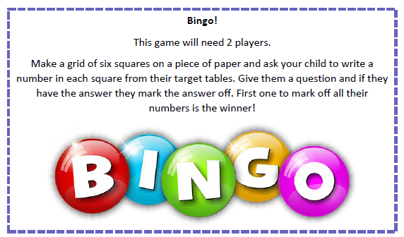
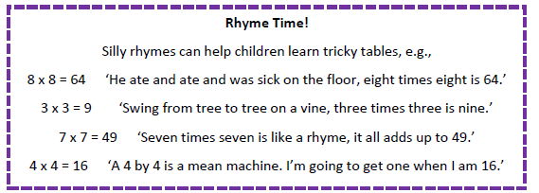
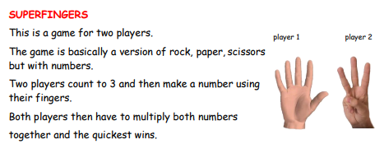
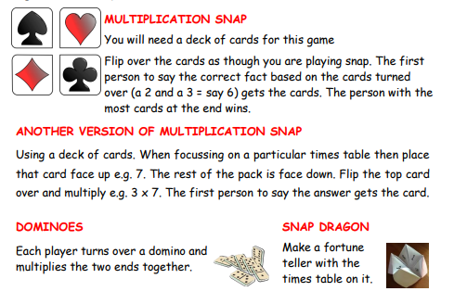
Times tables Exercises/ Dance Moves
- Skipping and hopscotch can be combined with chanting or singing times tables facts.
- Tell children they are working on the 7 times tables. Call out answers and pupils have to work out what the answer divided by 7 would be and then do that number of star jumps etc.
- Put times tables answers around a space, call out a fact, children have to run and touch the answer a quickly as possible.

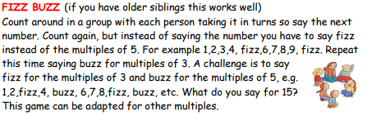
Tricks and Patterns
Below is a list of patterns and strategies which can be used to help learn times tables facts:
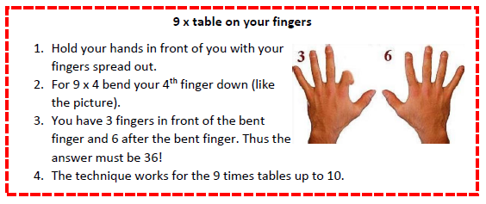
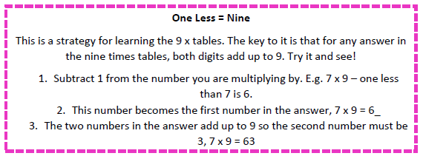

6 x 10 times tables using your fingers.
Watch the video
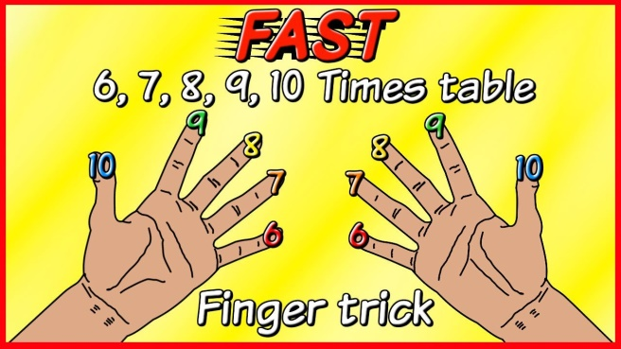
https://www.youtube.com/watch?v=x2Nr-f02AUY

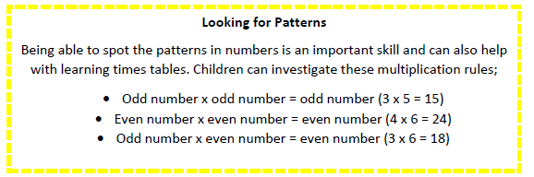
Doubling:
When multiplying by 2 double it, 2 x 3 = double 3 is 6.
When multiplying by 4 double it and double again. 4 x 3 = double 3 is 6, double 6 =12.
When multiplying by 8 double it, double it, double again! 8 x 3 = double 3 is 6, double 6 is 12, double 12 is 24!
Halving:
If I know 6 x 10 = 60, then I know 6 x 5 = 30 because 5 is half of ten and 30 is half of 60.
If I know 6 x 4 is 24, then I know 3 x 4 is 12 because 3 is half of 6 and 12 is half of 24.
11 and 12 times table:
11 x 3 is the same as 10 x 3 = 30 + 3 = 33
12 x 3 is the same as 10 x 3 = 30 + 2 x 3 = 36

Ask questions:
How does knowing 5 x 4 = 20 help you work out 6 x 4? I know that 10 x 7 = 70, how can I use that to find 9 x 7? If I know that 20 x 3 = 60, what else do I know?
Known Facts:
Free our working memory by removing facts we don’t struggle to remember.
0 x table will always be 0, 1 x tables , 10 tables, 11 tables digits going up.

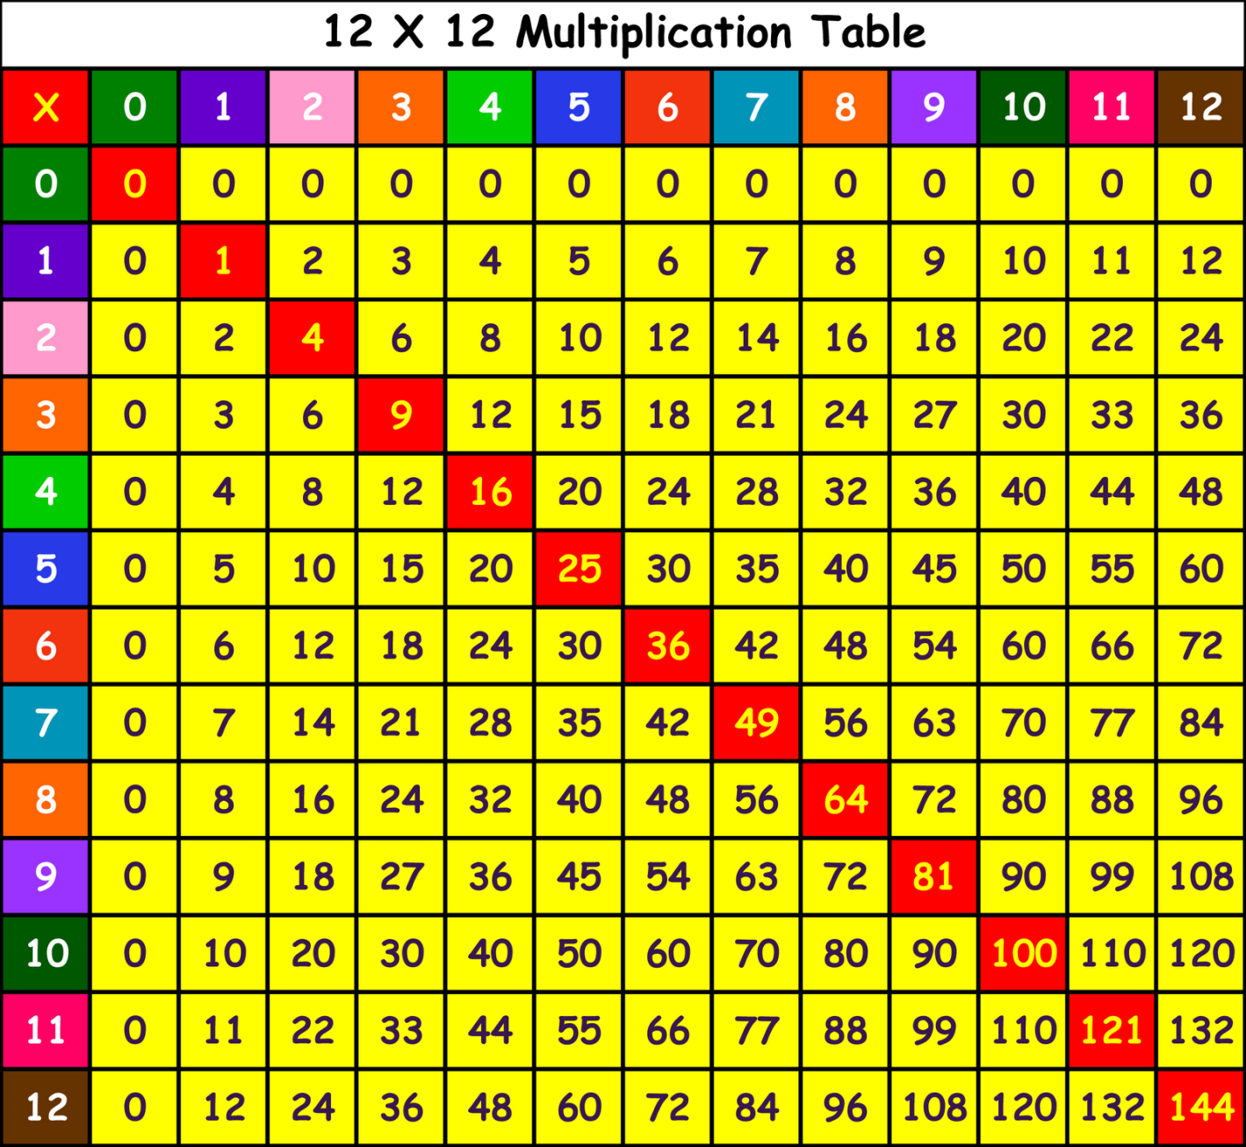
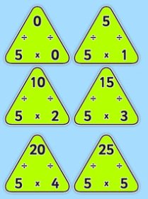
Square numbers can be a good hook point or bridging step. If pupils remember the square numbers they can use these as a point from which to calculate other times tables facts.
Pupils should learn that table facts are related: e.g. 3 x 4 = 12 so 4 x 3 = 12 so 12 ÷ 3 = 12.
Times tables Triangles are a great way of teaching this.

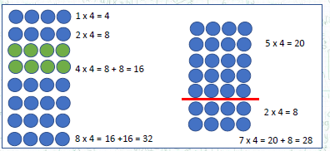
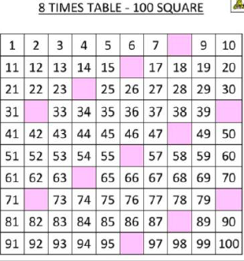

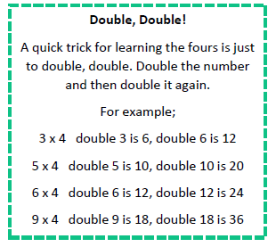
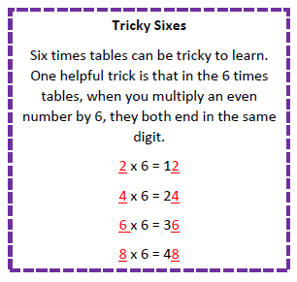
Rapid Recall and Learning Tips
We will be doing weekly tests in school. Your child’s teacher will communicate with you via Class Dojo which times tables will be tested. This will be a combination of times tables when pupils are more fluent.
How can you help?
-Use flash cards to help your child learn their times tables facts in any order.
- Practise writing down the times tables in order and then reverse order.
- Use a variety of multiplication and division questions to ensure pupils are confident and flexible with their knowledge.
- Timed quizzes – can they better their score or speed?
- Use these quizzes to identify facts that your child finds difficult.
- Display times tables poster or tricky facts somewhere easily seen.
Get creative in the ways the ways that you practise:
