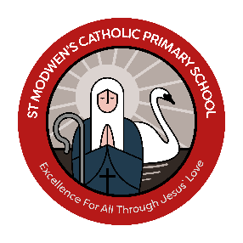



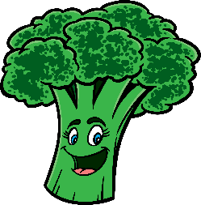
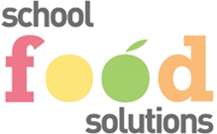
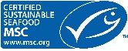
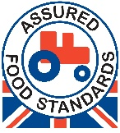
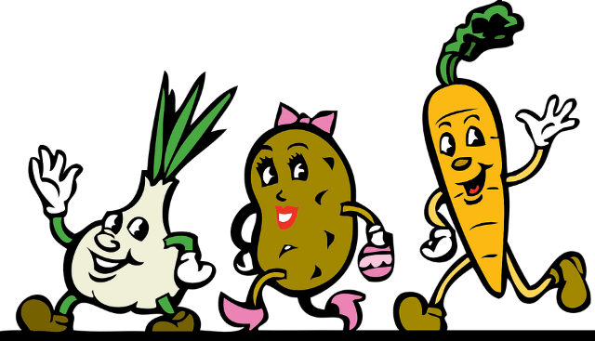

Fish Fingers
or
Omelette (V)
͠
Chips
͠
Seasonal Vegetables
͠
Dessert of the Day

Roast Turkey
served with
Yorkshire Pudding
or
Cheese Pie (V)

͠
Roast Potatoes
Seasonal Vegetables
͠
Dessert of the Day

Cottage Pie
or
Beany Enchiladas (V)
͠
Pomme Potatoes
͠
Seasonal Vegetables
͠
Dessert of the Day

Pork Sausages
or
Quorn Sausages (V)
͠
Alphabites
͠
Seasonal Vegetables
͠
Dessert of the Day

Homemade Pizza (V)

served with
Seasonal Wedges
͠
Seasonal Vegetables
͠
Dessert of the Day
Monday

Friday
Wednesday
AVAILABLE DAILY
FRESH MIXED SALAD, JACKET POTATOES, served with Cheese, Baked Beans, Tuna Mayo, Salad
FRESH FRUIT SALAD, ASSORTED FRUIT YOGHURTS,
ASSORTED HOMEMADE SANDWICHES cheese or ham
CHEESE & BISCUITS
(All Menus Are Subject to Change)

All allergen information is kept within the school kitchen and available upon request

Tuesday
W/C 01/09/26 W/C 21/09/26 W/C 12/10/26 W/C 02/11/26 W/C 23/11/26 W/C 14/12/26
Thursday
Lunch Menu Week 1




Battered Fish
or
Omelette (V)
͠
Chips
͠
Seasonal Vegetables
͠
Dessert of the Day

Chicken Goujons
or
Veggie Nuggets (V)
͠
Herby Potatoes
͠
Seasonal Vegetables
͠
Dessert of the Day

Roast Gammon
served with
Yorkshire Pudding
or
Quorn Sausage (V)
͠
Creamed Potatoes
Seasonal Vegetables
͠
Dessert of the Day

Wednesday

Chichen Tikka Curry
served with
Rice & Naan Bread
or
Quorn Bolognaise
Served with Pasta (V)
͠
Seasonal Vegetables
͠
Dessert of the Day

Beef Burger or
Quorn Burger (V)
͠
Seasoned Wedges
͠
Seasonal Vegetables
͠
Dessert of the Day
Friday
Thursday
Monday
AVAILABLE DAILY
FRESH MIXED SALAD, JACKET POTATOES served with Cheese, Baked Beans, Tuna Mayo, Salad,
FRUIT SALAD, ASSORTED FRUIT YOGHURTS,
ASSORTED HOMEMADE SANDWICHES cheese and ham
CHEESE & BISCUITS
(All Menus Are Subject to Change)

All allergen information is kept within the school kitchen and available upon request

Tuesday
W/C 07/09/26 W/C 28/09/26 W/C 19/10/26 WC/ 09/11/26 W/C 30/11/26
Lunch Menu Week 2

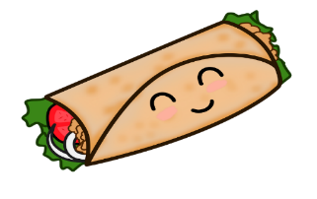


Thursday

Beef Bolognaise
Served with Garlic Bread
or
Veggie Tikka with Rice and Naan
͠
Creamed Potatoes
͠
Seasonal Vegetables
͠
Dessert of the Day

Fish Fingers
or
Omelette (V)
͠
Chips

Seasonal Vegetables
͠
Dessert of the Day
Friday

Roast Turkey
served with
Yorkshire Pudding
or
Vegan Roll (V)
͠
Roast Potatoes
͠
Seasonal Vegetables
͠
Dessert of the Day

Wednesday

Cheese & Tomato Pizza (V)
͠
Seasoned Wedges

͠
Seasonal Vegetables
͠
Dessert of the Day

Mini Brunch
(Pork Sausage, Omelette)
or
Vegetable Fingers (V)
͠
Hash Brown
͠
Seasonal Vegetables
͠
Dessert of the Day

Monday
AVAILABLE DAILY
FRESH MIXED SALAD, JACKET POTATOES, served with Cheese, Baked Beans, Tuna Mayo, Salad
FRESH FRUIT SALAD, ASSORTED FRUIT YOGHURTS,
ASSORTED HOMEMADE SANDWICHES cheese or ham
CHEESE & BISCUITS
(All Menus Are Subject to Change)

All allergen information is kept within the school kitchen and available upon request

Tuesday
W/C 14/09/26 W/C 05/10/26 W/C 16/11/26 W/C 13/04/26 W/C 7/12/26

Lunch Menu Week 3

